A Fairness Tool for Bias in FR

Alice Loukianova, Dylan Dasgupta, Rohan Krishnamurthi, William Cutler, Joseph Robinson

Figure 1: **BFW Image set** [1]. Various faces from the Balanced Faces in the Wild (BFW) database used to establish an unbiased identification method by representing each race and gender to the same extent.

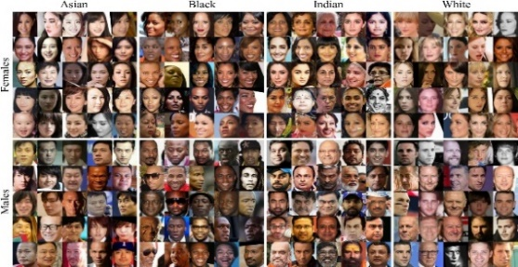

Abstract

We develop a means to diagnose bias in facial recognition (FR) (*see Table 1*) systems, an issue causing unequal access to the technological benefits of AI for certain subgroups. Specifically, we present an easy-to-use dashboard tool that outlines the extent to which a given FR algorithm is biased and for which subgroups this bias is most severe. We evaluate the FR system against a state-of-the-art Balanced Faces in the Wild database (BFW) (s*ee Figure 1*), which is balanced by gender, ethnicity, and subgroup to ensure an accurate and unbiased evaluation. Our dashboard is complete with a variety of interactive plots for visual analysis of FR bias from multiple perspectives. These tools contribute toward fairness in AI by providing users the ability to recognize and address the biases of their FR models.

# Introduction

F

acial recognition (FR) is a rapidly expanding form of machine learning (ML) technology ranging in use from personal device security and social media to surveillance. Bias occurs when an FR algorithm systematically performs better on images belonging to certain subgroups over others. Indicators of a better performance include a lower false positive rate (FPR) or a higher true positive rate (TPR). Performance metrics such as these can be analyzed through visualizations such as the confusion matrix, DET curve, SDM curve, and the ROC curve (*see Figures 2,3,4,5)*. When separated by gender, ethnicity, or subgroup, these plots can provide an on-demand analysis of the bias in a given FR algorithm.

In order to construct these plots for a given FR system, the model must be evaluated against a data set of faces. It is imperative that the data set used is balanced in terms of all subgroups (i.e., gender, ethnicity, and their intersection), or else the evaluation itself suffers from the same biases we seek to eliminate.

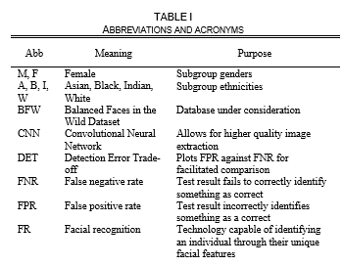

***Table 1****. The acronyms, abbreviations, and their respective definitions used throughout the paper*

By taking a balanced dataset of people from diverse backgrounds, tests can be confidently run to see where bias occurs and which subgroups are affected the most (*see Figure 1).* Our dashboard tool *(see figure 8)* grants users the ability to leverage our balanced data set for their bias evaluation. It dynamically generates multiple visualizations to offer different perspectives on the unique nature of the bias of a given FR algorithm, and because of our intuitive dashboard layout and well-documented visualizations, our tool is accessible to anyone with an FR model outside of ML research.

## Motivation

Not only is FR technology used in a wide variety of fields and locales, it is also pervasive in areas very sensitive to bias, with estimates indicating as many as 117 million Americans are affected by its use in law enforcement [2]. When used frequently in serious scenarios such as police investigations, the bias in FR represents more than an inconvenience; it’s a legitimate civil rights concern.

Because FR is a developing field, regulations and evaluation metrics have not been extensively developed. A complete

solution does not currently exist, so the proliferation of tools for measuring bias furthers overall progress to ensuring equity in AI in practice.

Evaluating bias in FR algorithms is a monumental task in part due to two significant obstacles that we have identified. The first is the lack of a publicly available dataset that is balanced among ethnicity, sex, and the combination of the two, against which FR models could be tested. The second is that every FR

algorithm is biased in its own unique ways, so there is an intrinsic need for an evaluation that is automatic and custom-tailored to a given algorithm.

By implementing an easy-to-use dashboard that analyzes the bias of a given FR algorithm against our balanced dataset, we work to solve both problems simultaneously.

***Table 2. Gender and Race Database Statistics:*** *Statistics of the Balanced Faces in the Wild (BFW) [1] database, grouped here by subgroup and a specific value. There are a million pairs total under analysis, with a constant 30,000 positive pairs being assessed for each gender under said subgroup. Overall, F performs inferior to M for I and W, while M performs inferior to W for A and B.*

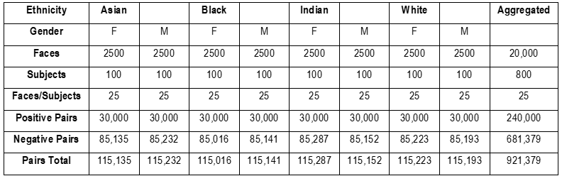

# Prerequisite information

Facial recognition software is a method of analyzing a person through facial features. By using biometrics to map an individual’s face, it can create an identity and find a match within its database to confirm to whom the face belongs. FR has a vast range of applications and usage, from security to marketing and far more that we may not even be aware of. Police and FBI agents agree that our lives are safer because of FR technology [3], without which, could leave many crimes unsolved and suspects roaming free. This concept has been around for nearly a century but has only become increasingly popular over the last several years as more severe security measures have become necessary for the population’s well-being. It is fair to say that FR transformed the world of security and identification. Although it represents the next level in biometric identification, to progress further we need to resolve the bias present in our current identification methods. Otherwise, this bias will continue to hinder us from perfecting FR technology unless a fairness tool can be created and implemented.

## Facial Recognition (FR)

The FR industry is expected to grow immensely over the next

half-decade and nearly double in industry value [4]. FR works similarly to how we identify people in our lives. By looking at someone we know, we can give them a name and identity based on their physical appearance and unique attributes. The FR software performs this more systematically and algorithmically, to ensure the match in their database is perfect. There are certain key features on one’s face that can be used to identify a person such as the distances between the eyes, forehead and chin, and nose to the chin. This advanced technology has only become more complex and useful. Researchers in Japan have found a way to use FR to detect fevers in humans [5], allowing automatic detection of illnesses such as COVID-19 and more. FR has been used to identify missing children and even pets stored in their database [6]. With our increasingly tech-dependent world, FR is one of the most useful forms of technology available. It facilitates nearly all processes and wherever we do not think it is applicable, it soon will be.

## Bias in FR

Facial recognition has been in use since the 1960s in the United States, and it has only progressed in terms of accuracy and feasibility. However there remain unsolved issues that violate social justice values and prevent the software from being perfect. One of the major problems discovered with FR technology is the bias in identifying a user depending on their demographic [7]. For example, females tend to experience more errors with FR than males, and with respect to ethnicity Asians encounter the most errors. By categorizing users into eight subgroups, based on ethnicity and gender, the bias becomes far easier to target and understand. The four ethnicities we have looked at are: white, Asian, black, and Indian; the two genders are male and female (*see Table 2).* While there is an opportunity to consider additional subgroups, these eight best categorize all users in a more general sense. One way we demonstrate this bias is the confusion matrix (*see figure 2),* whichdisplays the percent error encountered between each ethnicity and gender. This visualization shows that Asian females will experience the most bias, while white males will encounter the least.

## Similar Technology

## We are not the first group to investigate this bias, as many frontier companies specialize in FR[8]. There is countless software made in an attempt to perfect FR and an endless consumer supply. Nearly half of U.S residents with a smartphone own an iPhone, which utilizes FR software to allow access to the device. FR is ubiquitous in everyday life, without us even being aware, in airports, public venues, stores, and so many more locations [9]. It has become a part of basic technology to assist groups with various tasks that all concern identification. There is no need for tedious database searching or matching pictures anymore, FR facilitates all these processes in different ways. FR is not the first method of biometric security, and certainly not the last. It is a stepping stone in the advancement of cybersecurity measures. Fingerprint identification, commonly known as “touch ID” is another example of biometric identification, it is a more out-of-date method, but nonetheless works in a similar fashion to FR. Companies like Apple and LG are using FR as payment methods for purchases made through their devices [10]. Rather than having to confirm details manually, a user’s device will confirm the buyer through their FR cameras. Any software that utilizes a large database of humans/living organisms or has some process of identification through biometrics can be considered similar to FR. The software and processes behind FR technology are so complex and involved that it is hard to believe most of these interfaces can be so simple.

*Figure 2:* ***Confusion matrix.*** *The error (%) for the various faces of BFW vs. all others. AF performs the worst as WM performs the best, meaning AF is confused most often. This shows that subgroups are useful for FR because we can break each category/group down to analyze which genders and which races are being confused the most.*

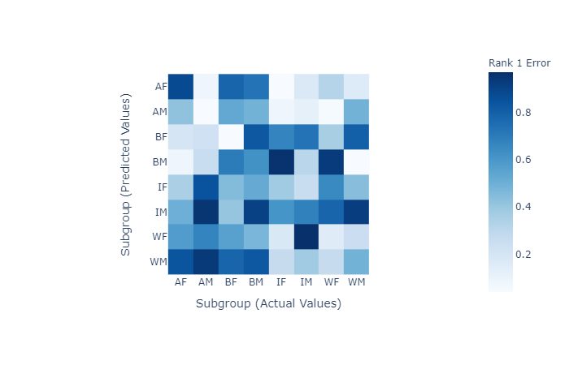

# Measuring Bias

In this section some methods for measuring bias in facial recognition will be explored.

A confusion matrix *(see figure 2)*  is a very useful tool for measuring recall, precision, specificity, and accuracy in a model.

Recall measures how much was correctly predicted out of all the positive cases.

(1)

Precision looks at how many cases are truly positive out of the positive ones predicted correctly.

(2)

Specificity is a measure of how correct the true negative rate is.

(3)

Accuracy looks at how much was predicted correctly out of all the classes.

(4)

The value of a given cell corresponds to the extent to which an image belonging to the subgroup in that row was matched incorrectly with an image from the subgroup in the corresponding column. Naturally, these errors coalesce at the diagonals since it is more likely to confuse an image with another from the same subgroup. Since the model displayed below measures errors, lower diagonal values would indicate a model that is better at making predictions. The model tends to discriminate the best between white male (WM) faces and the worst between Asian female (AF) faces with the highest number being in the top left of the matrix and the lowest in the bottom right. This really emphasizes that the subgroups are meaningful and distinct.

Another effective plot is the Detection Error Trade-off (DET) Curve which is a plot of measured error rates and shows the false negative rate (FNR) as a function of the false positive rate (FPR). This shows the tradeoff between sensitivity with the FPR and specificity with the FNR. A false positive occurs when two images are incorrectly declared as a match (i.e., the same person), this is a Type 1 Error. A false negative occurs when two images of the same person are not identified as a match, this is a Type 2 Error. The three DET plots below *(see figure 3)* show a comparison between genders, ethnicities, and the subgroups. These plots are all based on the assumption of a global threshold meaning it’s constant for each subgroup.

In *Figure 3*, the curve representing male faces is lower meaning that it performs better. For the plot of ethnicities, the lowest curve is for a white ethnicity and the highest represents an Asian ethnicity, indicating the model performs the best on white faces and the worst on Asian faces. Similarly, for the subgroups, the lowest curve belongs to white males and the highest belongs to Asian females. The main takeaway is that a threshold varying across different subgroups would perform better than a global one and can yield a constant FPR.

**Figure 3: Detection Error Tradeoff (DET)** curves across genders (left), ethnicities (right), and subgroups(bottom). Lower is better. Baseline random guessing shown in grey.

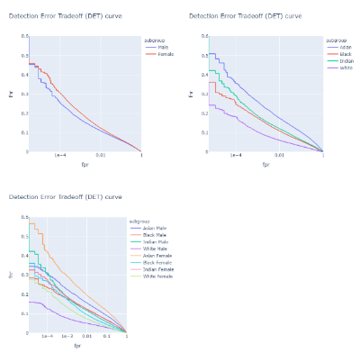

Another visualization is a signal detection model (SDM). In *Figure 4*, the SDM curves across subgroups show a discrete distribution of scores. The imposter scores (in blue) have a median at 0 and follow a gaussian pattern with most of the variation across subgroups occurring in the upper percentiles, while genuine pairs (in orange) vary in both the lower and upper percentiles. Generally, less overlap between genuine scores and imposter scores is better. In *Figure 4*, the highest area of overlap between the genuine and the imposter pairs occurs for the Asian female subgroup. In comparison, there is virtually no overlap for the white male subgroup, which consistently has the best performance.

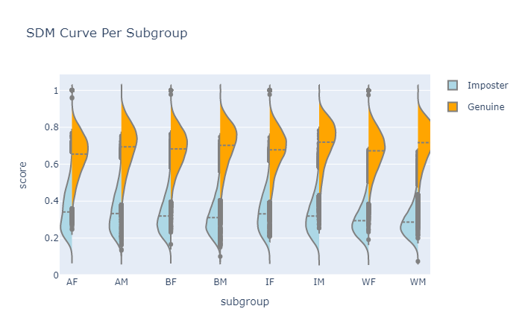

**Figure 4: Signal detection model (SDM)** across subgroups

The last tool for performance measurement to be discussed is the Receiver Operating Characteristic (ROC) curve. The ROC is a probability curve with true positive rate (TPR) plotted against the false positive rate (FPR).

(5)

(6)

This means that the top left corner, where the false positive rate would be 0 and the true positive rate would be 1, is the ideal spot for a perfect model. This is very idealistic and not usually the case, however other indicators of a good model are a larger area under the curve and a steeper curve. The steeper the curve the more the TPR is maximized and the FPR is minimized. The ROC curve clearly displays the inverse relationship between sensitivity and specificity: as sensitivity increases the specificity decreases. In *Figure 5*, the ROC curves for gender, ethnicities, and subgroups can be seen. In *Figure 5*, the curve representing male faces is steeper and has a larger area under the curve indicating better performance. Similarly, for subgroups, the steepest curve with the most area under the curve belongs to the white male subgroup.

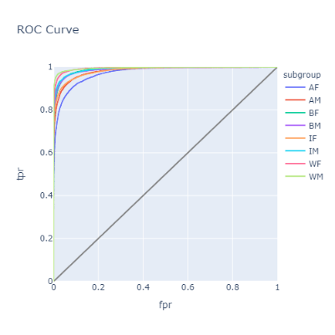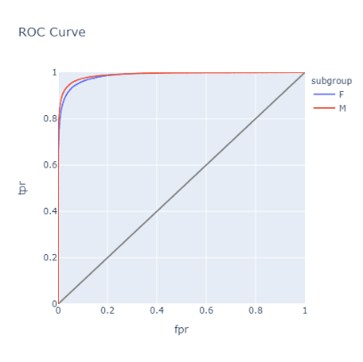

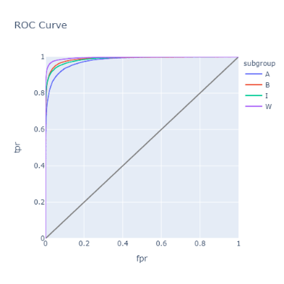

**Figure 5: Receiver Operating Characteristic (ROC)** curves across subgroups (left), genders (right), and ethnicities (bottom). Higher is better. Baseline random guessing shown in grey.

# The dashboard

## Who is the dashboard for?

The dashboard is intended for those looking to fully understand the bias in their own FR models. Each of the plots previously discussed can be recreated with a different set of data through the dashboard. Researchers interested in FR can utilize the dashboard to evaluate their models, rather than testing it on their own. Students involved in FR, whether through research, coursework, or other motivation can use the dashboard as a great learning tool [11]. Someone who wants clean visual aids, as well as an in-depth explanation of how we can arrive at these plots, can look to the dashboard for more technical related questions.

## Implementing the Data

Figure 6: Dashboard Data Flow: This diagram shows how data is read and stored by the dashboard throughout its processes.

The most important step in creating the dashboard was developing a flow for the data and understanding how it would interact with the components as the user interacts with the dashboard GUI. A data flow was created to show the optimization of time and efficiency *(see* *figure 6)*.

When the dashboard is first opened, it loads and presents the default dataset – *bfw-v0.1.5-datatable[1]* [1]. The default data is stored as a pickle file in the app’s directory. The user is also given the option to upload their own dataset. If he/she chooses to do so, the dataset is first checked to see if it conforms to the requirements of the dashboard. If so, the data is relabeled and converted to a pickle file, which is then stored in the *cache-directory* folder of the app’s directory. From there, either the default or newly cached data’s pickle file is read by three components of the dashboard - the data preview, score distribution, and error evaluation sections. While being read from the cache, the filters specified by the user are applied to the dataset. The filtered data is then displayed in the tables presented in the data preview section and the charts are shown in both the score distribution and error evaluation sections.

## Frontend-Backend Interaction

Figure 7: Callback Graph

While the backend of the dashboard follows the flow shown in *Figure 6*, the frontend of the dashboard had to be designed to keep up with the many user interactions while communicating them to the backend.

The primary component with the most critical connections is the ‘upload-data’ component. This component triggers the callback that contains the first three steps of the data flow shown in *Figure 6*. When the dashboard is initialized, the callback reads the default data to be shared with the rest of the dashboard. If the user uploads his/her own data via the ‘upload-data’ component, the callback is triggered again and the data is validated, cached, and read by the rest of the dashboard. It connects to the ‘output-data-upload’, ‘data-table-div’, ‘summary-table-div’, ‘tabs-content-dist’, and ‘tabs-content-error’. The connection denotes that any time ‘upload-data’ is triggered, the connected components are all updated. It is this connection that automatically updates all the charts and plots whenever the data is updated.

The ‘ethnicity-filter’, ‘gender-filter’, and ‘score-filter’ components represent the three global filters that are applied to all the charts and plots in the dashboard. Whenever the filters are updated, the data is read from the cache with the filters applied and sent to the ‘data-table-div’, ‘summary-table-div’, ‘tabs-content-dist’, and ‘tabs-content-error’ components. The ‘column-filter’ component only affects the layout of the data preview, so its only connection is to ‘data-table-div’.

The tabs are represented by the ‘error-tabs’, ‘dist-tabs’, and ‘data-tabs’ components, which are connected to ‘tabs-content-error’, ‘tabs-content-dist’, and ‘tabs-content-data’, respectively. Whenever a tab is selected, the value is sent to the child and the contents of the tab are updated.

## Dashboard Components

Figure 8: Dashboard Layout

##### Data Upload

The data upload component is where the user can upload his/her own dataset. The dataset can either be dragged and dropped directly onto the component, or the component can be clicked, which will prompt a file directory to appear, allowing the user to select a dataset. This component was built using the *dash_core_components[2]* (DCC) library’s*Upload* component. The *Upload* component allows users to upload CSV files into the dashboard, which is then read as a base64 encoded string that contains the filename and location.

##### Global Filters

The filters located below the data upload component are dropdown filters that apply to the entire dashboard. By default, all genders and ethnicities are selected, and the scoring metric is set to ‘senet50’. Whenever the user changes any of the filters, the data is re-read with the filters applied. These filters were created using the DCClibrary’s *Dropdown* component. The *Dropdown* component takes either multiple values as a list or single values as a string, which is read by each of the visualization components and applied to the dataset.

##### Data Preview and Data Summary

The Data Table and Data Summary tabs on the dashboard enable the user to preview the dataset and the summary statistics of it. When the dataset is read, a random subset of the data is taken and displayed in the Data Table tab. This data table is reactive to the global filters and has an additional column filter, which allows the user to show and hide specific columns in the data preview. The Data Summary tab provides the user with a numerical breakdown of the dataset categorized by subgroup. The counts shown in this table represent the entire dataset and are also reactive to the global filters. Both tables were created using a combination of *Pandas*[3] and the *Dash DataTable[4]* library. Pandas is used to create the tables and calculate the dataset summary, while Dash DataTable is used to convert the Pandas tables to the interactive HTML tables shown on the dashboard.

##### Score Distribution & Error Evaluation

The score distribution and error evaluation components are dropdown sections created using HTML’s Summary and Details elements. When either heading is clicked, a series of tabs containing various visualizations are revealed. The tabs were created using the DCC library’s*Tabs* and *Tab* components. The *Tab* component controls the style, value, and contents of each individual tab, while the *Tabs* component holds multiple *Tab* components together. At both the score distribution and error evaluation components the global filters are taken in and applied to the data being read, which is then passed to *Plotly[5]*to create the visualization denoted by the selected tab.

The score distribution component contains a violin plot, box plot, and SDM curve detailing the distribution of scores across each subgroup. The violin plots and box plots provide the same insight as the SDM Curves which are shown and described in *Figure 4*. The error evaluation component contains the DET curves (see *figure 3)*, ROC curves (see *figure 5)*, and confusion matrix (see *figure 2)*.

# Discussion and Future

FR software is just the beginning of a new wave of advanced biometric cybersecurity measures that use human features to protect one’s device. Initially, fingerprint identification was created in the late 1800s [12], then came FR shortly after, and we have only progressed from there. Creating a fair method of evaluating users is key to the future of biometric security, and if this issue remains present, the advances made in this field are automatically limited by this prevalent dilemma. If these biases continue to exist in FR, they will propagate to more advanced applications such as retina scanners. FR has been used to help countless people and is far more useful than one might imagine. Police use FR to track down suspects and prevent further crimes from happening. Airports use FR to locate passengers or possible suspects to ensure their customers don’t have to worry [13]. The list goes on: shopping centers, law enforcement, and more. FR is only just beginning to assist our world, by perfecting the technology and creating a completely unbiased method to assess users, the possibilities are endless.

# References

1. Robinson, Joseph P., et al. "Face Recognition: Too Bias, or Not Too Bias?." *arXiv preprint arXiv:2002.06483* (2020).
2. Bedoya Alvaro., et al. “The Perpetual Lineup.” Center on Privacy and Technology, Georgetown Law, 18 Oct. 2016,

https://www.perpetuallineup.org/

1. Valentino-devries, Jennifer. “How the Police Use Facial Recognition, and Where It Falls Short.” *The New York Times*, The New York Times, 12 Jan. 2020, [www.nytimes.com/2020/01/12/technology/facial-recognition-police.html](http://www.nytimes.com/2020/01/12/technology/facial-recognition-police.html).
2. Symanovich, Steve. “How Does Facial Recognition Work?” *Official Site*, us.norton.com/internetsecurity-iot-how-facial-recognition-software-works.html.
3. Singer, Natasha, and Cade Metz. “Many Facial-Recognition Systems Are Biased, Says U.S. Study.” *The New York Times*, The New York Times, 19 Dec. 2019, [www.nytimes.com/2019/12/19/technology/facial-recognition-bias.html](http://www.nytimes.com/2019/12/19/technology/facial-recognition-bias.html)
4. Marr, Bernard. “Facial Recognition Technology: Here Are The Important Pros And Cons.” *Forbes*, Forbes Magazine, 19 Aug. 2019, [www.forbes.com/sites/bernardmarr/2019/08/19/facial-recognition-technology-here-are-the-important-pros-and-cons/#7533dba314d1](http://www.forbes.com/sites/bernardmarr/2019/08/19/facial-recognition-technology-here-are-the-important-pros-and-cons/#7533dba314d1).
5. Saravanan, Raja, and Raja Saravanan. “Facial Recognition Can Give Students Better Service (and Security).” *Ellucian*, www.ellucian.com/insights/facial-recognition-can-give-students-better-service-and-security.
6. “Best Facial Recognition Software.” *Analytics Insight*, 29 Nov. 2019, www.analyticsinsight.net/best-facial-recognition-software/.
7. German, Ed. *History of Fingerprints*, onin.com/fp/fphistory.html.
8. Martin, Nicole. “The Major Concerns Around Facial Recognition Technology.” *Forbes*, Forbes Magazine, 25 Sept. 2019, [www.forbes.com/sites/nicolemartin1/2019/09/25/the-major-concerns-around-facial-recognition-technology/#79bd0e704fe3](http://www.forbes.com/sites/nicolemartin1/2019/09/25/the-major-concerns-around-facial-recognition-technology/#79bd0e704fe3).
9. Writer, Staff. “Japan Chipmaker Unveils AI Face Recognition Tool to Detect Fever.” *Nikkei Asian Review*, Nikkei Asian Review, 23 Apr. 2020, asia.nikkei.com/Spotlight/Coronavirus/Japan-chipmaker-unveils-AI-face-recognition-tool-to-detect-fever.
10. iTech Post. “10 Interesting Facts about Facial Recognition.” *ITech Post*, 24 Apr. 2020, www.itechpost.com/articles/102434/20200424/10-interesting-facts-about-facial-recognition.htm.
11. Alexandre, Ana. “LG's IT Subsidiary Uses Facial Recognition Tech for Payments With Digital Currency.” *Cointelegraph*, Cointelegraph, 23 Apr. 2020, cointelegraph.com/news/lgs-it-subsidiary-uses-facial-recognition-tech-for-payments-with-digital-currency.
12. Elmahmudi, Ali, and Hassan Ugail. “The Effect of FaceAgeing in Face Recogntion.” EasyChair Preprints, May 2019, doi:10.29007/8vms.
13. Singh, Prabhjot, et al. “The Review of Various Methods and Color Models in Face Recogntion.” 2018 Fifth International Conference on Parallel, Distributed and Grid Computing (PDGC), 2018, doi:10.1109/pdgc.2018.8745847.
14. Yao, Min, and Changming Zhu. “SVM and Adaboost-Based Classifiers with Fast PCA for Face Reocognition.” 2016 IEEE International Conference on Consumer Electronics-China (ICCE-China), 2016, doi:10.1109/icce-china.2016.7849742.

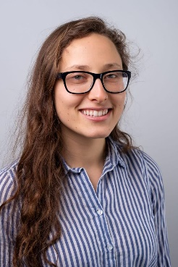Alice Loukianova was born on October 23, 1998 in Teaneck, NJ. Alice Loukianova is currently an undergraduate student at Northeastern University (NEU) set to receive a B.S. in mechanical engineering in Spring 2021. She has been a research assistant in the Lab for Neuromodulation and Neuromuscular Repair (2016-2017) as well as the Occupational Biomechanics and Ergonomics Lab (2017-2018), a joint lab between MIT and NEU. At NEU she has held many leadership positions serving as Design Lead for a project in Enabling Engineering, President of the Biomedical Engineering Society, Lab Safety Technician for Aerospace NU, VP for Advocacy for the Resident Student Association, Outreach Coordinator for Academic Enrichment for Student Government, Leadership Associate for the Center for Student Involvement, and Service Learning Mentor for the GE1501/1502 classes. This year her leadership positions include being the Build Studio Hardware Engineer in the Generate Product Development Studio at NEU, as well as being VP for Recognition in NEU’s National Residence Hall Honorary chapter. She has also completed two co-ops at Nova Biomedical (2018) and at Desktop Metal (2019), she currently works as a Machine Shop Assistant in the Mechanical and Industrial Engineering Machine Shop at NEU in Boston, MA. Ms. Loukianova is a member of The American Society of Mechanical Engineers (ASME) as well as The Society of Women Engineers (SWE).

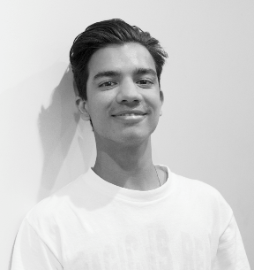Dylan Dasgupta is a student at Northeastern University on track to receive a BS in Industrial Engineering and a minor in Data Science in December of 2020. His past co-ops were at Liberty Mutual Insurance as a Continuous Improvement Analyst (Boston, 2018) and Rue Gilt Groupe as an Advanced Analyst (Boston, 2019). Former leadership positions include Vice President of External Affairs for the Northeastern Interfraternity Council (2018-2019). Some of his past work can be found on GitHub at github.com/ddasgupta4



Rohan Krishnamurthi is an industrial engineering student at Northeastern University (NEU) in Boston, MA, class of 2022, with minors in computational data analytics and Mathematics. Graduate of Saint John’s High School (2014-2018) with honors including AP scholar, National Honors Society, High Honor Roll, and varsity athlete. Former occupations include a teacher for Kumon of America (2014-2018), quality assurance at BL Healthcare (2018), and a basketball coach for the town of Ashland (2015-2017). His recent projects completed are Optimization of Medical System’s Transportation Methods (2019) and UniqueShoes Store and Database Design (2019). He plays the guitar at Northeastern and is involved in the Institute of Industrial Engineers (IISE), the Actuarial Club, and the South Asian Society of Engineers(SASE). He has tutored students at all levels including Calculus, Geometry, and Chemistry throughout high school and basic Mathematics and English to elementary students in London, UK.

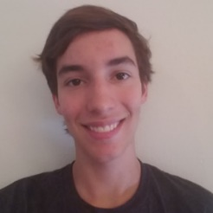William R. Cutler is an undergraduate Computer Science/Physics student at Northeastern University (NEU) in Boston, MA, Class of 2023. He currently works as a Teaching Assistant for the Khoury Colleges of Computer Science at NEU, assisting with the Fundamentals of Computer Science course (Jan. 2020). Previous teaching assistant positions include TA for Agoura High School’s advanced physics course (2018-2019), and Tutor at the Kumon Math and Reading Center in Agoura Hills, CA (2017 – 2018). He has also worked as a Research Assistant for the Zhang Computational Materials Science lab in at California State University, Northridge in the field of electrocatalysis, studying reactions that occur in hydrogen fuel cells. He has held multiple leadership positions including President of the Math Honor Society, co-founder and VP of History Honor Society, and attorney co-captain of Mock Trial team. Through classes, clubs, and on his own, he has completed many software projects, including a recreation of the classic game “Centipede”, code to handle wireless data transfer from remote control to robotic vehicle, a simulation experiment to study the game theory of the ultimatum game, and two applications published in the Google Play store: a puzzle game and a productivity tracker. He is an avid clarinetist, performing for NEU’s Wind Ensemble and Symphony Orchestra, and also an Eagle Scout.

1. <https://github.com/visionjo/facerec-bias-bfw>
2. https://dash.plotly.com/dash-core-components
3. https://pandas.pydata.org/docs/
4. https://dash.plotly.com/datatable
5. https://plotly.com/python/